|  |  |
| --- | --- |
| **EX.NO:10** | **MINI PROJECT – REGIONAL TRANSPORT OFFICE MANAGEMENT SYSTEM** |
| **16/09/2017** |

**AIM:**

To implement the regional transport office management system.

**OBJECTIVE:**

* To understand the concept of problem statement
* To understand the concept of UML diagrams for the given project.
* To understand the concept of database connectivity and jsp.

**SOFTWARE REQUIRED:**

NetBeans IDE 7.4, Google Chrome, SQL Workbench.

**PROBLEM STATEMENT:**

Regional Transport Office is a web based application that supports the organization of events that occurs which are conducted by a person who is hired maintain an event and make it success. RTO is used to keep track the Citizen’s License details with the validity of the vehicles being tracked. Citizen has a username and a password to access the details on their account and to importantly take account of their vehicle details and the validity of the license. Citizen can also keep track of the laws with are being altered by the government. The Portal also keeps account of the Citizen’s right to apply for a license and the details are updated into the database.

**UML DIAGRAMS:**

**USECASE DIAGRAM:**



**CLASS DIAGRAM:**

**SEQUENCE DIAGRAM:**



**COLLABRATION DIAGRAM:**



**STATE CHART DIAGRAM:**



**ACTIVITY DIAGRAM:**



**PACKAGE DIAGRAM:**



**COMPONENT DIAGRAM:**

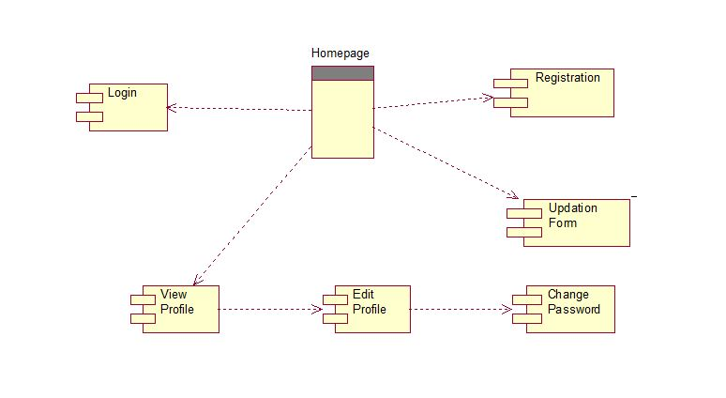

**DEPLOYMENT DIAGRAM:**

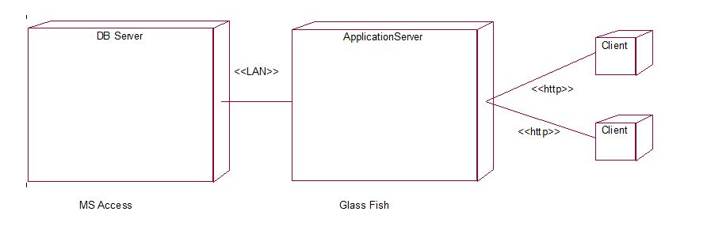

**PROGRAM:**

**Login.jsp:**

<html>

<head>

<title>Login</title>

<meta name="viewport" content="width=device-width, initial-scale=1">

<link rel="stylesheet" href="https://maxcdn.bootstrapcdn.com/bootstrap/3.3.7/css/bootstrap.min.css">

<script src="https://ajax.googleapis.com/ajax/libs/jquery/3.2.1/jquery.min.js"></script>

<script src="https://maxcdn.bootstrapcdn.com/bootstrap/3.3.7/js/bootstrap.min.js"></script>

<style>

.modal-header, h4, .close {

background-color: #5cb85c;

color:white !important;

text-align: center;

font-size: 30px;

}

.modal-footer {

background-color: #f9f9f9;

}

</style>

</head>

<body background="21.jpg">

<div class="container">

<font color=White><hr>

<center><h1> Login Driver :-</h1></center>

<hr>

<br><br><br>

<center><h2>Citizen, Enter your details:-</h2>

<img src="Login1.png" length=300 width=200>

</center></font>

<center><button type="button" class="btn btn-default btn-lg" id="myBtn">Login</button></center>

<!-- Modal -->

<div class="modal fade" id="myModal" role="dialog">

<div class="modal-dialog">

<!-- Modal content-->

<div class="modal-content">

<div class="modal-header" style="padding:35px 50px;">

<button type="button" class="close" data-dismiss="modal">&times;</button>

<h4><span class="glyphicon glyphicon-lock"></span> Login</h4>

</div>

<div class="modal-body" style="padding:40px 50px;">

<form action="LoginServlet" method="post">

<div class="form-group">

<label for="usrname"><span class="glyphicon glyphicon-user"></span> Username</label>

<input type="text" class="form-control" name="usrname" id="usrname" placeholder="Enter email">

</div>

<div class="form-group">

<label for="psw"><span class="glyphicon glyphicon-eye-open"></span> Password</label>

<input type="text" class="form-control" id="psw" name="psw" placeholder="Enter password">

</div>

<div class="checkbox">

<label><input type="checkbox" value="" checked>Remember me</label>

</div>

<button type="submit" class="btn btn-success btn-block"><span class="glyphicon glyphicon-off"></span> Login</button>

</form>

</div>

<div class="modal-footer">

<button type="submit" class="btn btn-danger btn-default pull-left" data-dismiss="modal"><span class="glyphicon glyphicon-remove"></span> Cancel</button>

<p>Not a member? <a href="Signup1.html">Sign Up</a></p>

</div>

</div>

</div>

</div>

</div>

<script>

$(document).ready(function(){

$("#myBtn").click(function(){

$("#myModal").modal();

});

});

</script>

</body>

</html>

**loginservlet.java:**

import java.io.IOException;

import java.io.PrintWriter;

import static java.lang.System.out;

import java.sql.Connection;

import java.sql.DriverManager;

import java.sql.ResultSet;

import java.sql.Statement;

import javax.servlet.ServletException;

import javax.servlet.http.HttpServlet;

import javax.servlet.http.HttpServletRequest;

import javax.servlet.http.HttpServletResponse;

import javax.servlet.http.HttpSession;

public class LoginServlet extends HttpServlet {

protected void processRequest(HttpServletRequest request, HttpServletResponse response)

throws ServletException, IOException {

response.setContentType("text/html;charset=UTF-8");

try (PrintWriter out = response.getWriter()) {

String name=request.getParameter("usrname");

String pass=request.getParameter("psw");

Class.forName("com.mysql.jdbc.Driver");

Connection con=DriverManager.getConnection("jdbc:mysql://localhost:3306/sys?zeroDateTimeBehavior=convertToNull", "root", "root");

Statement stmt=con.createStatement();

String query="SELECT * FROM RTO WHERE STUID='"+name+"' AND PASS='"+pass+"'";

HttpSession session=request.getSession(true);

ResultSet rs=stmt.executeQuery(query);

int found=0;

while(rs.next()){

String stuid;

found++;

stuid= rs.getString("stuid");

out.println("<script type=\"text/javascript\">");

out.println("alert('Login Successfull');");

out.println("location='Portal.jsp';");

out.println("</script>");

session.setAttribute("stu",stuid);

}

if(found==0){

out.println("<script type=\"text/javascript\">");

out.println("alert('Incorrect username or password');");

out.println("location='Login.jsp';");

out.println("</script>");

}

}

catch(Exception e){

out.println(e);

}

}

protected void doGet(HttpServletRequest request, HttpServletResponse response)

throws ServletException, IOException {

processRequest(request, response);

}

protected void doPost(HttpServletRequest request, HttpServletResponse response)

throws ServletException, IOException {

processRequest(request, response);

}

public String getServletInfo() {

return "Short description";

}// </editor-fold>

}

**Signup1.jsp:**

<html>

<head>

<script type="text/javascript">

function validate_form()

{

if(document.register.name.value==="")

{

alert("Enter Valid Name");

return false;

}

if(document.register.email.value.indexOf("@",0)<0)

{

alert("Enter Valid Email id");

return false;

}

if(document.register.email.value.indexOf(".",0)<0)

{

alert("Enter Valid Email id");

return false;

}

var a=isNaN(document.register.number.value);

if(a===true)

{

alert("Enter Valid Phone Number");

return false;

}

alert("THANK YOU FOR VISITING !");

return true;

}

</script>

</head>

<body background="1.jpg">

<body style=color:White>

<br><br><br>

<hr><h1><center>Signup For A New Account.</center></h1><hr>

<center>

<form name="signup" action="apply">

<table border=10>

<tr>

<td>Driver Name:</td>

<td><input type="text" name="name" ></td>

</tr>

<tr>

<td>Gender:</td>

<td><input type="radio" name="gender" value="Female">Female

<input type="radio" name="gender" value="Male">Male</td>

</tr>

<tr>

<td>Citizens's EMAIL ID:</td>

<td><input type="email" name="email"></td>

</tr>

<tr>

<td>Address:</td>

<td><textarea rows="5" cols="30"></textarea></td>

</tr>

<tr>

<td>Phone Number:</td>

<td><input type="text" name="number"></td>

</tr>

<tr>

<td>Date Of Birth</td>

<td><input type="date" name="DOB"></td>

</tr>

<tr>

<td>Aadhar Number:</td>

<td><input type="number" name="anumber"></td>

</tr>

</table>

<hr>

<a href="Login.html">

<input type="submit" value="SUBMIT" onclick="validate_form()">

</a>

<input type="reset" value="RESET">

</form>

</center>

</bodystyle>

</body>

</html>

**Portal.jsp:**

<html>

<head>

<title>Portal</title>

<link rel="stylesheet" type="text/css" href="x1.css">

</head>

<body>

<div class="container">

<div class="first"><center><a href="laws1.html">LAWS</a></center></div><div class="third"><center><a href="Tt1.jsp">Validity</a></center></div>

<div class="second"><a href="Fees1.html">FEES</a></div><div class="fourth"><a href="Login1.html">Back to Login ?</a></div><div class="last"><a href="Aboutus1.html">ABOUT US</a></div>

</div>

</body>

</html>

**X1.css:**

head, body, .container

{

height: 100%;

min-height: 100%;

}

.first {

float: left;

width: 20%;

height: 30%;

background-color: red;

}

.second{

float: left;

width: 20%;

height: 70%;

background-color: green;

}

.third{

float: right;

width: 80%;

height: 80%;

background-color: orangered;

}

.fourth {

float: right;

width: 40%;

height: 20%;

background-color: #DDDDDD;

}

.last{

float: right;

width: 40%;

height: 20%;

background-color: yellow;

}

**Laws.jsp:**

<html>

<head>

<title>

Results

</title>

</head>

<body>

<a href="Portal1.html">BACK</a>

<hr>

<br><br><br>

<center>

<pre>

Services at Regional Transport Office Chennai:

Vehicle registration

Driving license; commercial as well as private

Permits for various routes

Taxes

Chennai Rto Form Download:

License Form:

License for learner

Driving license for fresher

Driving license renewal

Duplicate driving license

Vehicle of another class: Form 1, Form 1A

Registration temporary

Registration permanent

Registration certificate renewal

Ownership transfer

Ownership transfer if finance covered

No Objection Certificate issuance

Address change

Hire Purchase Agreement endorsement

Hire Purchase Agreement termination

Duplicate Radio Cab license form

Renewal/Issuance of Radio Cab license application form

Tourist Vehicle Permit form

National Permit or Tourist Permit Authorisation

National Permit Grant

Lading Bill form

Specific State Carriage Service Permit

Public Carrier National Permit

All India Tourist Vehicle Permit

Registration Form:

Chennai Rto Permit Form:

Permit for Specific Contract Carriage for Regular Use:

PTA

Special Permit Application form

Private Service Vehicle Permit

Specific Stage Carriage Permit

Stage Carriage Services Permit

Specific Contract Carriage Permit

Temporary Permit

Permit for Goods Carriage

Contact Details of Rto Office Chennai

To get contact details of various authorities at rto office Chennai, one should visit rto office Chennai website. On the home page of rto office Chennai, authorities are:

Commissioner Office

RTO

DTC

MVI Offices

Unit Offices

Stat

Check posts

Complaint making at regional transport office Chennai

Regional Transport Office Chennai Contact Number:

BSNL mobile/landline � 1100

Others � 1800 4251 110

Regional transport office Chennai online complaints: one should visit its website; click Register Via Internet button and register his complaint online

</pre>

</center>

</body>

</html>

**Tt1.jsp:**

<%@page import="java.sql.PreparedStatement"%>

<%@ page import="java.sql.ResultSet" %>

<%@ page import="java.sql.Statement" %>

<%@ page import="java.sql.Connection" %>

<%@ page import="java.sql.DriverManager" %>

<%@ page import="javax.servlet.http.HttpSession" %>

<html>

<head>

<title>

Results

</title>

</head>

<body>

<%

String username=(String)session.getAttribute("stu");

%>

<a href="Portal.jsp">BACK</a>

<hr>

<br><br><br>

<center>

<table border="10" >

<tr>

<th>CUSTOMER ID</th>

<th>VEHICLE </th>

<th>VEHICLE NAME</th>

<th>VALIDITY</th>

</tr>

<%

try {

Class.forName("com.mysql.jdbc.Driver");

Connection con=DriverManager.getConnection("jdbc:mysql://localhost:3306/sys?zeroDateTimeBehavior=convertToNull", "root", "root");

int found=0;

PreparedStatement ps= con.prepareStatement("select * from RTODETS where cid =?");

ps.setString(1,username);

ResultSet rs=ps.executeQuery();

while(rs.next())

{

found++;

%>

<tr>

<td><%=rs.getString("CID") %></td>

<td><%=rs.getString("VEHICLE") %></td>

<td><%=rs.getString("VNAME")%></td>

<td><%=rs.getString("VALIDITY") %></td>

</tr>

<%}

if(found==0)

{

out.println("<center>");

out.println("<h1>");

out.println("NO RECORD EXISTS");

out.println("</h1>");

out.println("</center>");

}

%>

</table>

<%

}

catch(Exception e)

{

e.printStackTrace();

}

%>

</center>

</body>

</html>

**Fees1.jsp**

<html>

<head>

<title>Fees</title>

<script type="text/javascript">

function validate_form()

{

if(document.register.cnum.value=="")

{

alert("Enter a Valid Card Name");

return false;

}

var a=isNaN(document.register.cvv.value)

if(a==true)

{

alert("Enter CVV Number");

return false;

}

alert("YOU HAVE REGISTERED FOR THE EXAM !");

return true;

}

</script>

</head>

<body background="">

<hr>

<h1><center>Exam Fees Payment</center></h1>

<hr>

<form>

<center>

<table border=10>

<tr>

<td>Card Number:</td>

<td><input type="text" name="cnum" required size=30></td>

</tr>

<tr>

<td>Card Provider:</td>

<td><input type="radio" name="cname" value="MS">MasterCard

<input type="radio" name="cname" value="VISA">VISA</td>

</tr>

<tr>

<td>CVV:</td>

<td><input type="text" name="cvv" required size=30 ></td>

</tr>

</table>

<hr>

<a href="feesu.jsp"><input type="submit" value="SUBMIT" onclick="validate_form()"></a>

<input type="reset" value="RESET">

</center>

</form>

</body>

</html>

**Feesu.jsp:**

<html>

<head>

<meta http-equiv="Content-Type" content="text/html; charset=UTF-8">

<title>JSP Page</title>

</head>

<body>

<h1><center><MARQUEE>THANKS FOR USING OUR SERVICE !</MARQUEE><BR><a href="Portal.jsp">Back</a></center></h1>

</body>

</html>

**Apply.jsp:**

<html>

<head>

<meta http-equiv="Content-Type" content="text/html; charset=UTF-8">

<title>EXAM APPLICATION</title>

</head>

<body background="A.jpg">

<h1><center>Apply for an Exam</center></h1>

<hr><center>

<form name="app" action="apply">

<table border=10>

<tr>

<td>Driver’s Number:</td>

<td>Gender:</td>

<td>ID Code:</td>

<td>Phone Number:</td>

<td>Vehicle Name:</td>

</tr><tr>

<td><input type="text" name="name" ></td>

<td><input type="radio" name="gender1" value="Female">Female

<input type="radio" name="gender2" value="Male">Male</td>

<td><input type="text" name="code"></textarea></td>

<td><input type="text" name="number"></td>

<td><input type="text" name="sub"></td>

</tr></table>

<hr>

<input type="submit" value="SUBMIT">

<input type="reset" value="RESET">

</form>

</body>

</html>

**Apply.java:**

import java.io.IOException;

import java.io.PrintWriter;

import static java.lang.System.out;

import java.sql.Connection;

import java.sql.DriverManager;

import java.sql.PreparedStatement;

import java.sql.ResultSet;

import java.sql.Statement;

import javax.servlet.ServletException;

import javax.servlet.http.HttpServlet;

import javax.servlet.http.HttpServletRequest;

import javax.servlet.http.HttpServletResponse;

import javax.servlet.http.HttpSession;

protected void processRequest(HttpServletRequest request, HttpServletResponse response)

throws ServletException, IOException {

String nam=request.getParameter("name");

String ec=request.getParameter("code");

String ph=request.getParameter("number");

String subname=request.getParameter("sub");

try (PrintWriter out = response.getWriter()) {

Class.forName("com.mysql.jdbc.Driver");

Connection con=DriverManager.getConnection("jdbc:mysql://localhost:3306/sys?zeroDateTimeBehavior=convertToNull", "root", "root");

PreparedStatement p=con.prepareStatement("INSERT into apply (stuno,code,ph,subject) VALUES(?,?,?,?);");

p.setString(1,nam);

p.setString(2,ec);

p.setString(3,ph);

p.setString(4,subname);

p.executeUpdate();

out.println("HELLO");}

catch(Exception e){

out.println(e);

}}

protected void doGet(HttpServletRequest request, HttpServletResponse response)

throws ServletException, IOException {

processRequest(request, response); }

protected void doPost(HttpServletRequest request, HttpServletResponse response)

throws ServletException, IOException {

processRequest(request, response);} public String getServletInfo() {

return "Short description";

}}

**DATABASE:**

**Rto:**

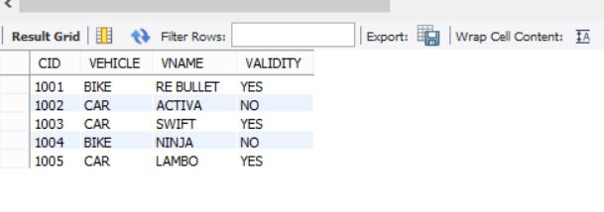

**Rtodets:**

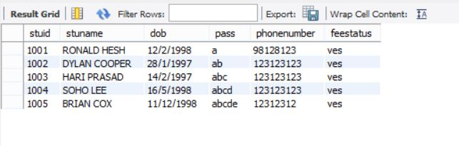

**Apply:**

**BEFORE:**

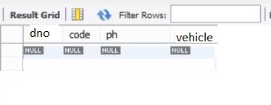

**AFTER:**

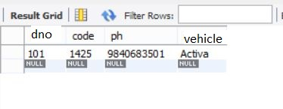

**OUTPUT:**

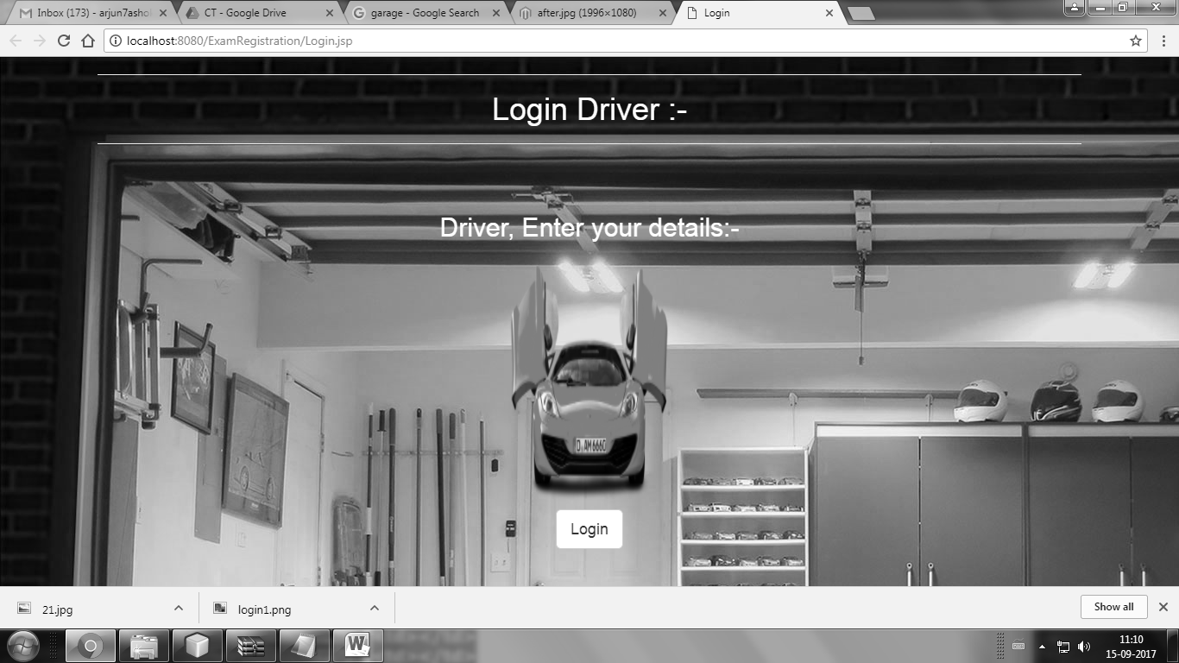

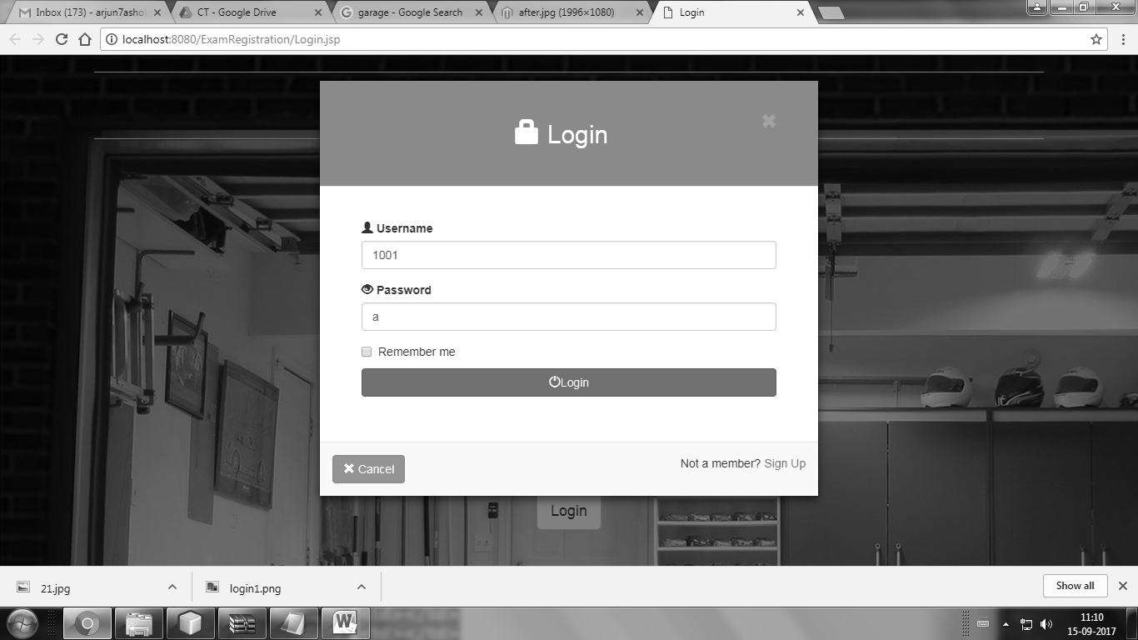

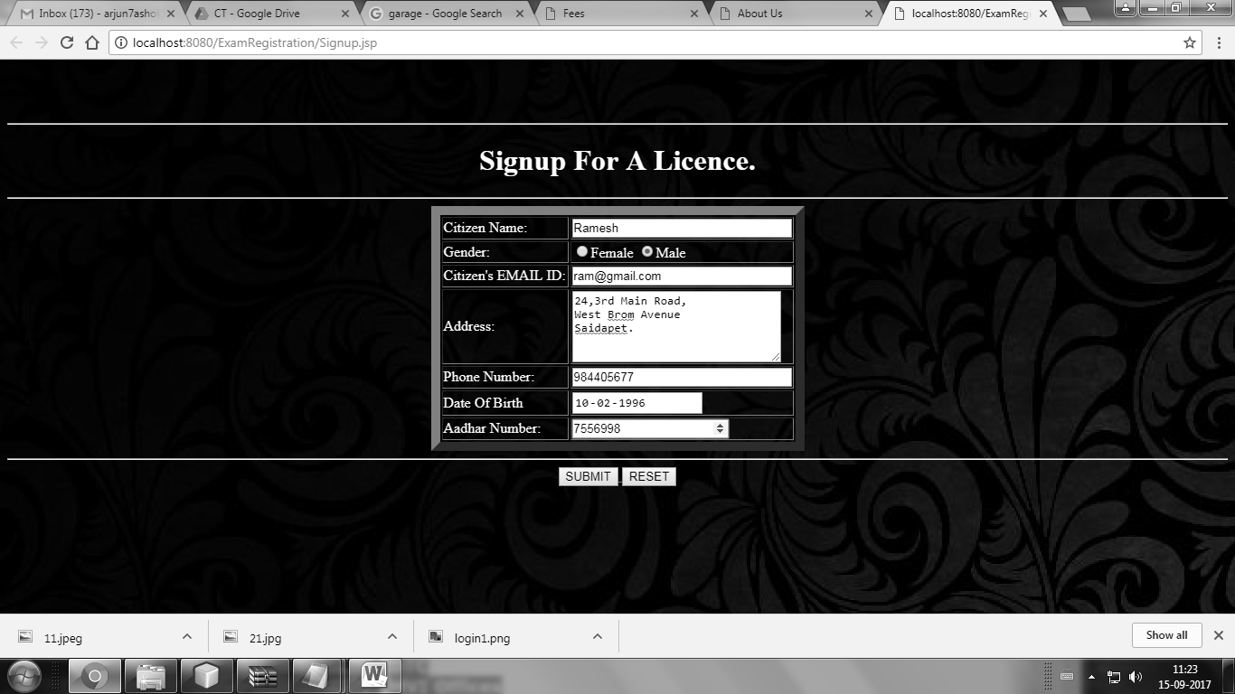

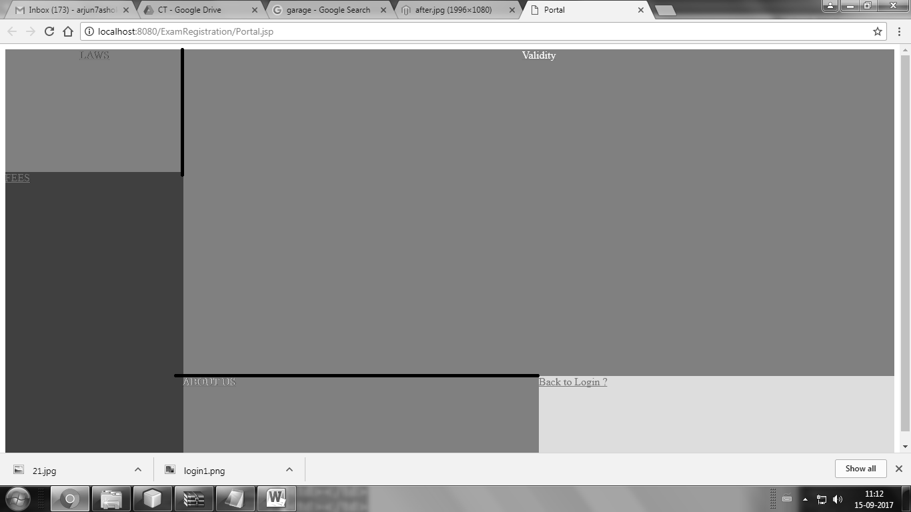

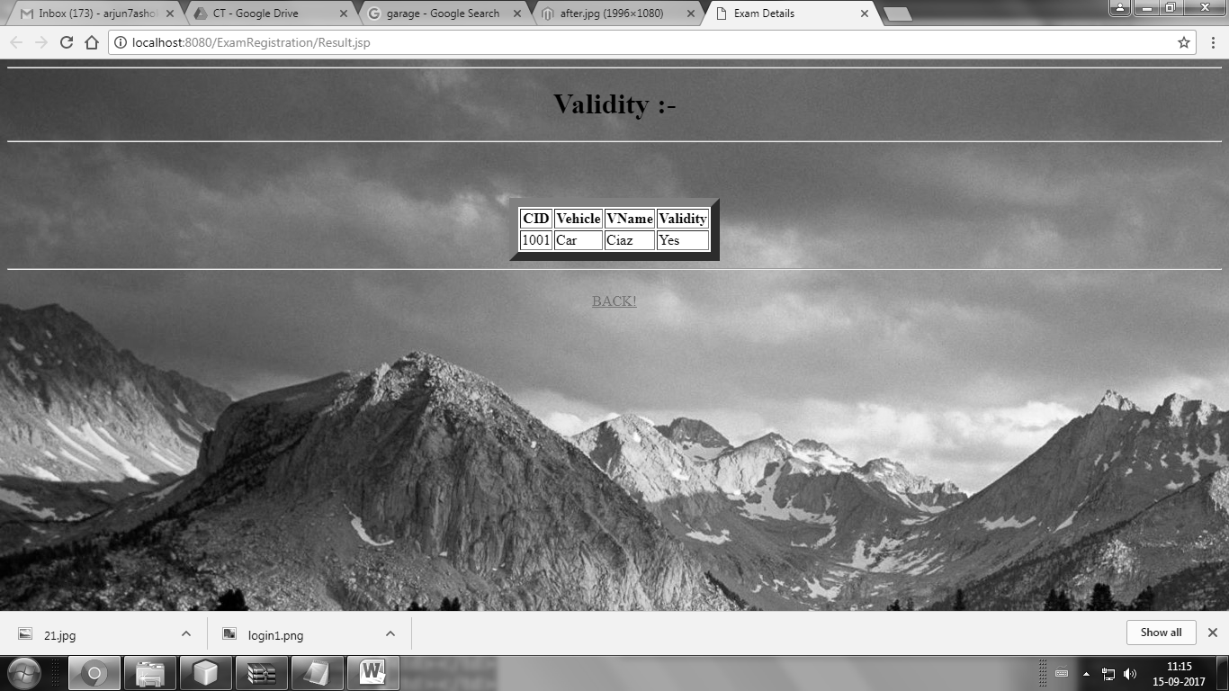

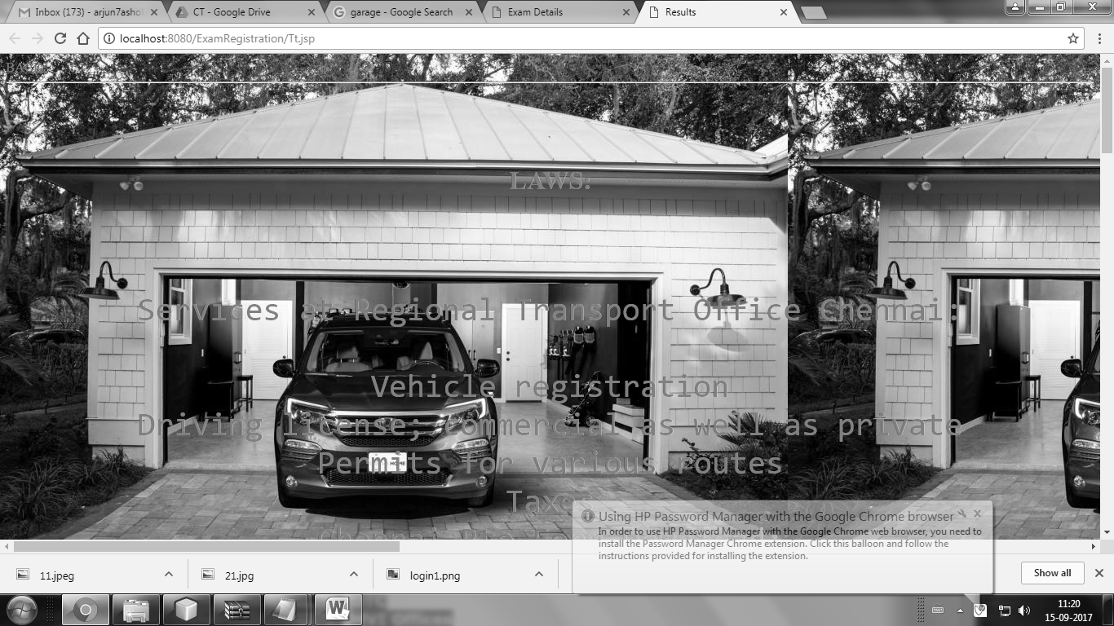

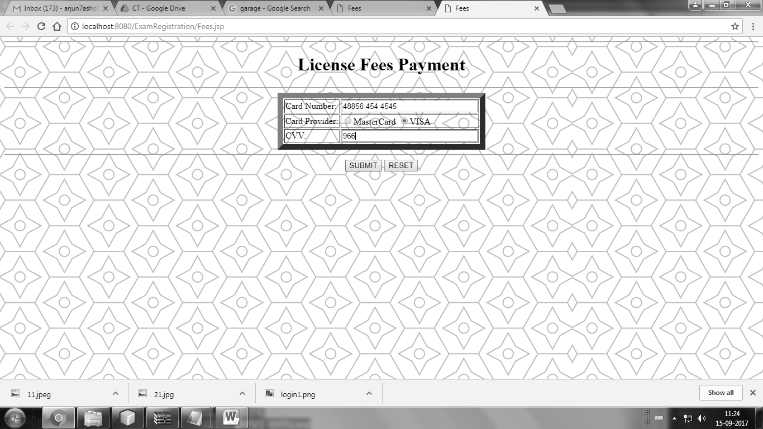

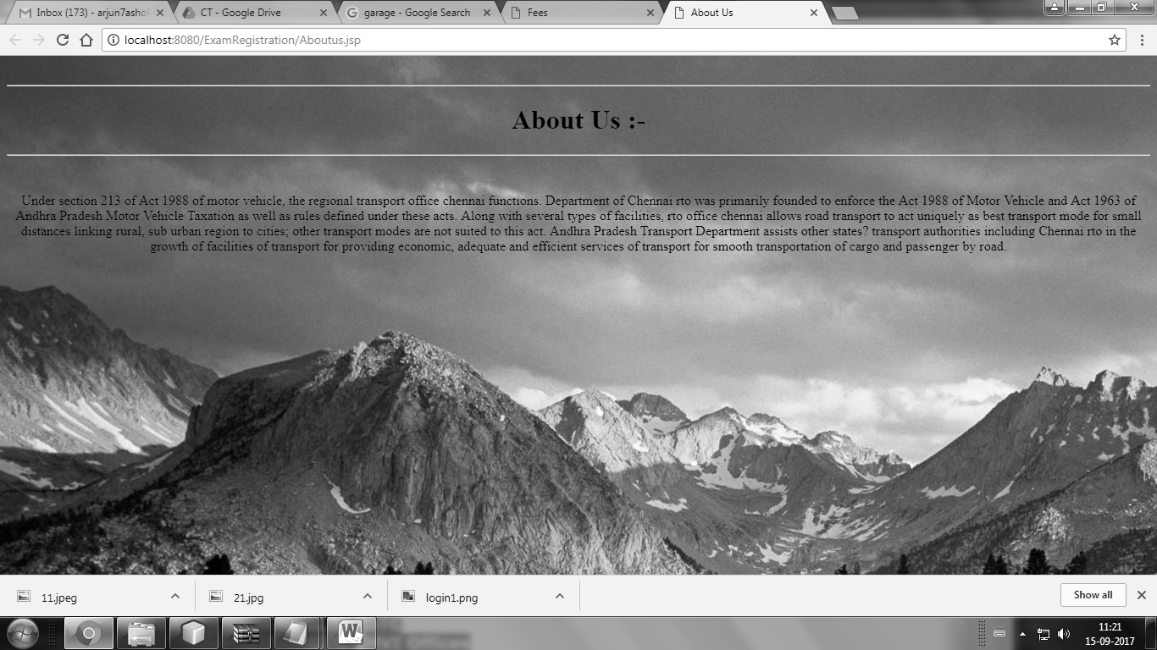

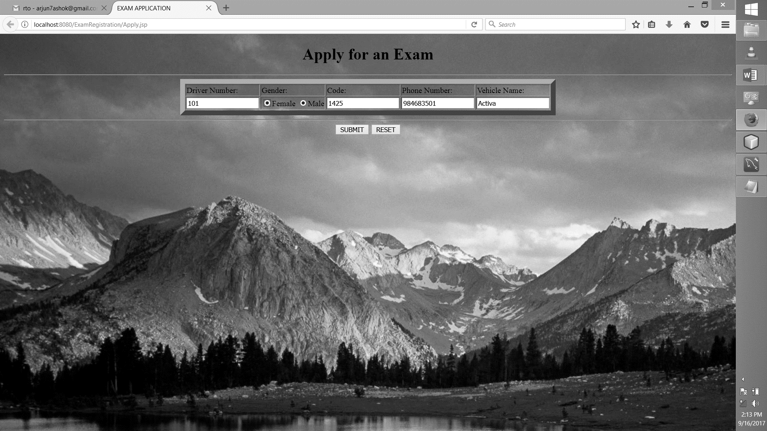

**RESULT:**

Thus, the Regional Transport Office System was implemented successfully.